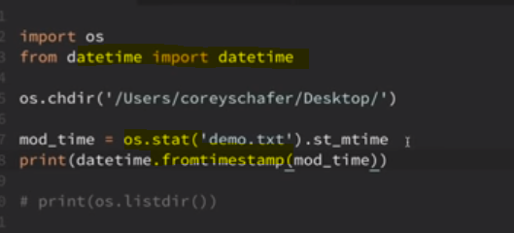

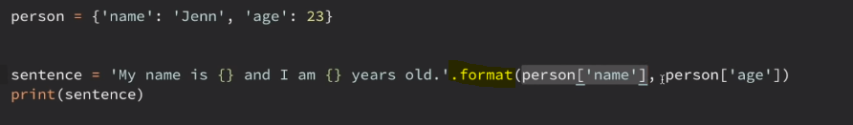

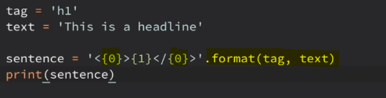

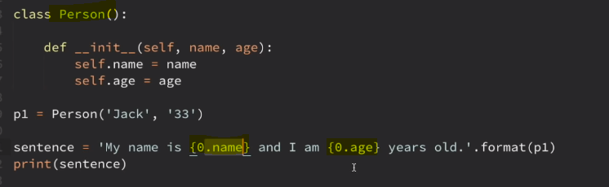

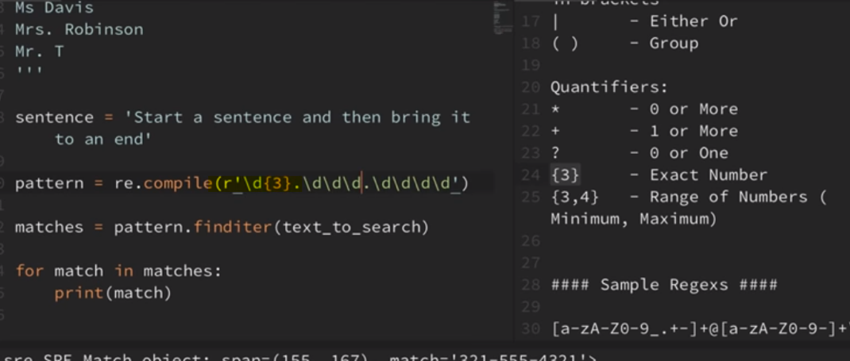

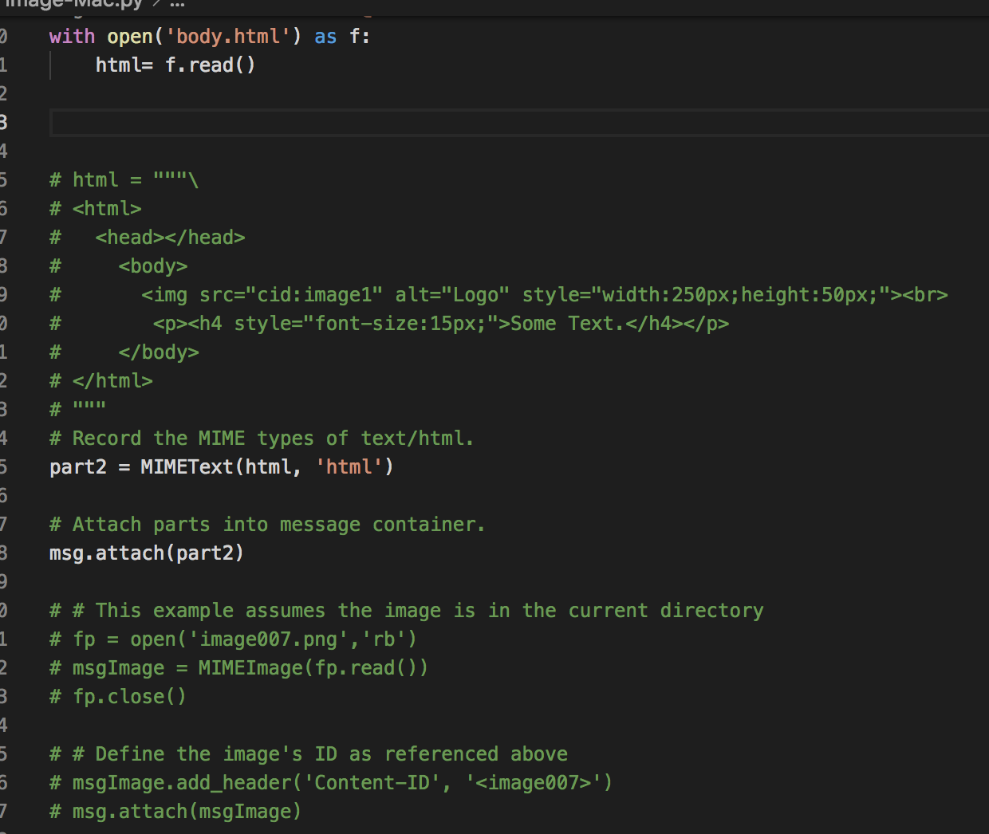

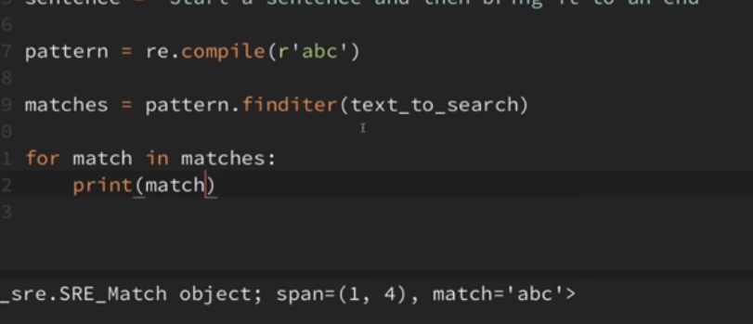

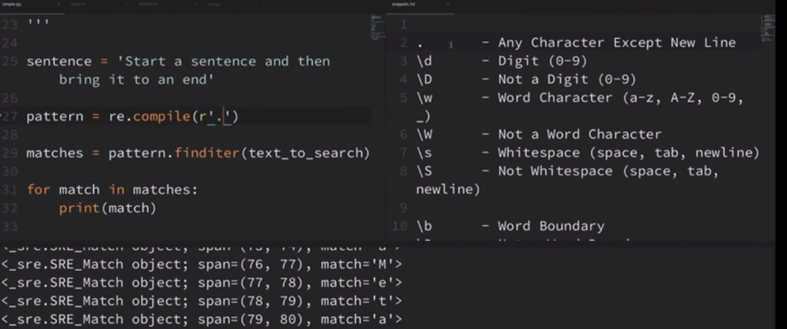

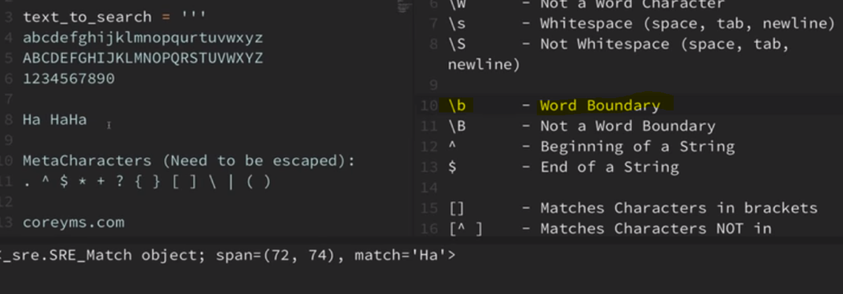

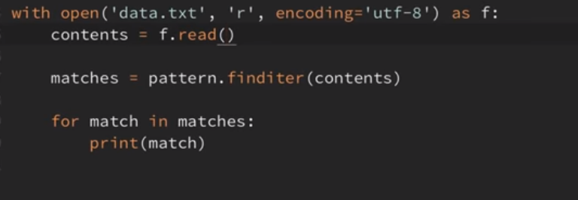

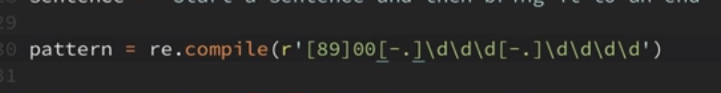

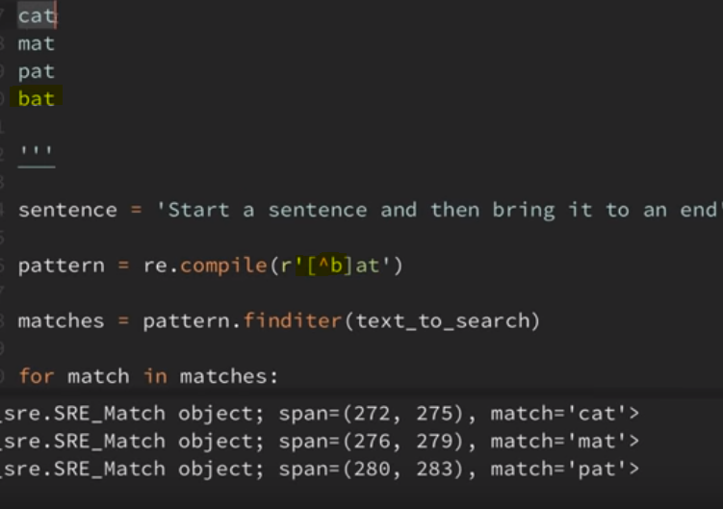

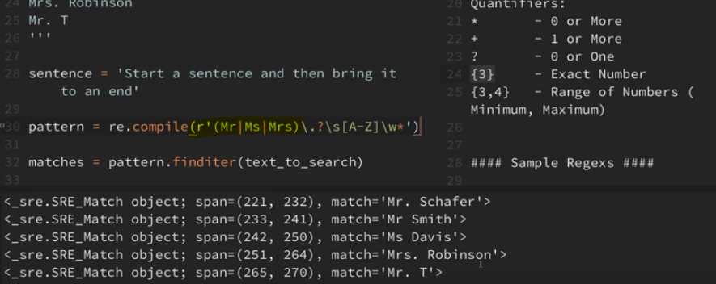

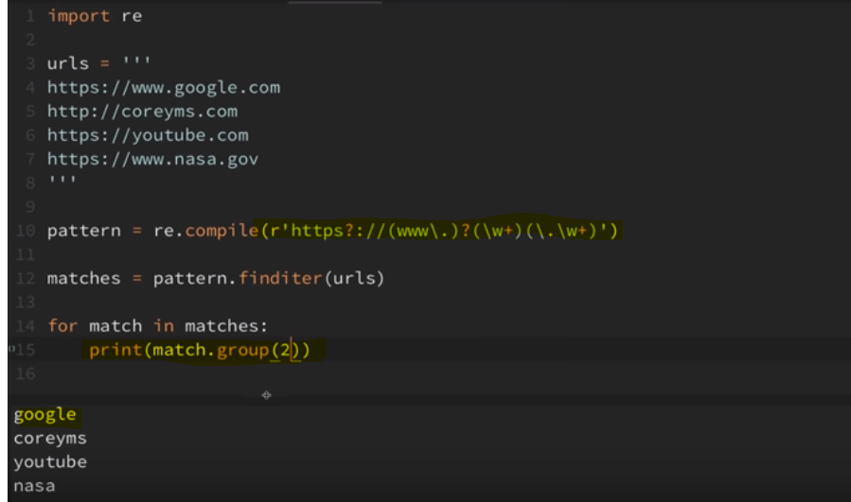

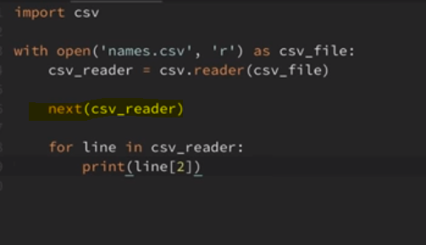

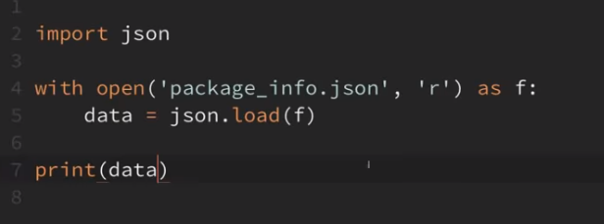

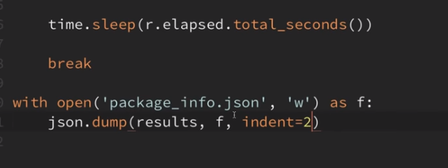

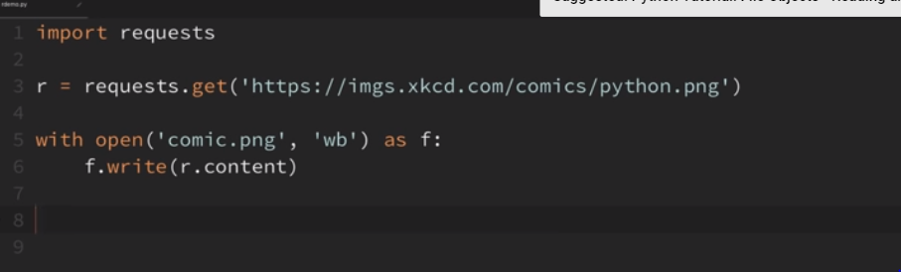

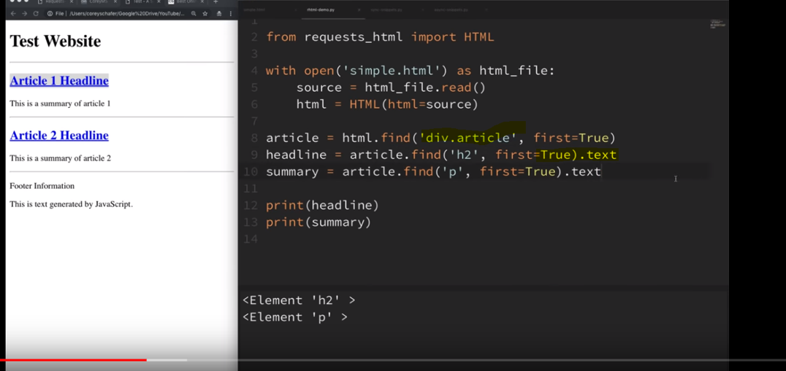

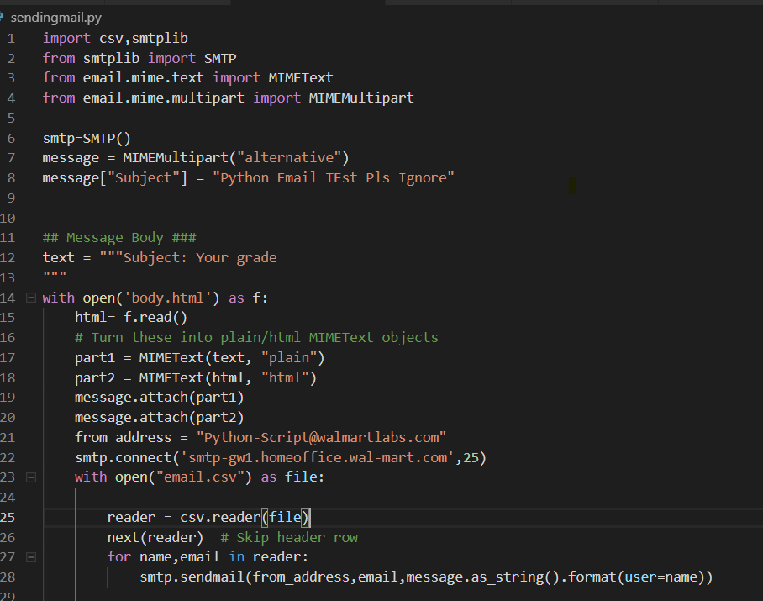

**## type copy availble in python.txt & complete powershel script availble in powershell doc**

**##Sending email using html file converted from Docx**

import smtplib,csv

from smtplib import SMTP

from email.mime.text import MIMEText

from email.mime.multipart import MIMEMultipart

from email.mime.image import MIMEImage

from email import encoders

def image():

with open('image002.png','rb') as fp :

msgImage = MIMEImage(fp.read(),_subtype='png')

msgImage.add_header('Content-ID', '<image002.png>')

return msgImage

def send():

with open('new1.html') as f:

html2= f.read()

# print(html1)

with open("email.csv") as file:

smtp = smtplib.SMTP('smtp-gw1.homeoffice.wal-mart.com')

reader = csv.reader(file)

next(reader) # Skip header row

for Associates,VM,Manager in reader:

msg = MIMEMultipart('related')

msg['Subject'] = "Action Required : DWS Notification"

html=html2.format(user1=Associates,name=VM,manager=Manager)

part2 = MIMEText(html, 'html')

msg.attach(part2)

msg.attach(image())

smtp.sendmail("ADE-IDC@walmart.com","kiran.chandran@walmartlabs.com",msg.as_string())

send()

**After converting html page == >> correct image file**

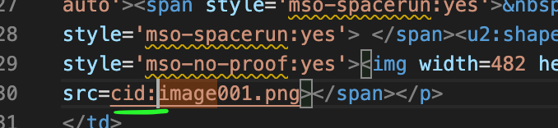

**PYTHON Package :**

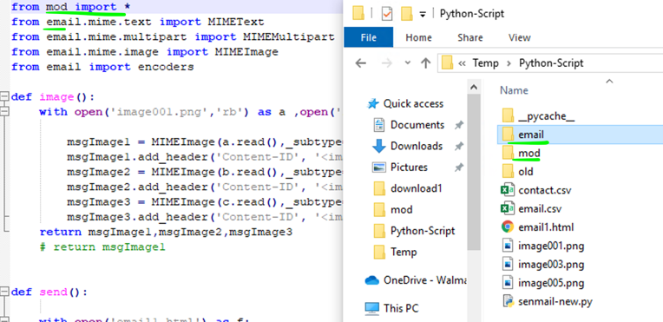

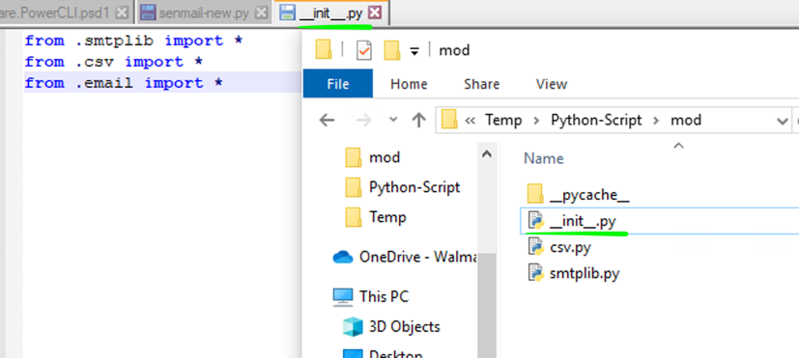

**mydict = {y[0]: y[1] for y in [x.split(",") for x in open('file.csv').read().split('\n') if x]}**

**## Writing csv file – adding rows**

data1=[]

with open("contact.csv", 'r') as file, open("contact1.csv", 'a+') as file1: # CSV file need to be updated for production

smtp = smtplib.SMTP('smtp-gw1.homeoffice.wal-mart.com')

reader = csv.DictReader(file)

writer = csv.writer(file1)

fieldnames = reader.fieldnames

fieldnames.append("Status")

writer.writerow(fieldnames)

for line in reader:

msg = MIMEMultipart('related')

msg['Subject'] = "Action Required : This message is sent to DWS Customers that haven’t used their VDI in at least 30 days"

msg['From'] = "DigitalWorkSpace@walmart.com"

msg['To'] = line['UserEmailAddress']

msg['Cc'] = line['ManagerEmail']

html=html2.format(username=line['UserDisplayname'],vm=line['VM'],day=SessionEndDate,dayleft=Remaindays)

part2 = MIMEText(html, 'html')

msg.attach(part2)

a=image()

msg.attach(a)

try:

smtp.send_message(msg)

line['status']="Success"

except:

line['status']="Failed"

data=[ value for key,value in line.items()]

data1.append(data)

writer.writerows(data1)

**Python Package :**

**How to write to JSON :**

**# Passing varible input to Powershell script.**

**with open('data.json', 'w') as outfile:**

**json.dump(data, outfile)**

**Read from powershell :**

$json = Get-Content .\data.json | Out-String | ConvertFrom-Json

**Tkinter App :**

**from tkinter import \***

**from tkinter.messagebox import \***

**import tkinter**

**from tkinter.filedialog import askopenfilename**

**import subprocess,json**

**def subprocess_cmd(command):**

**process = subprocess.Popen(command,stdout=subprocess.PIPE, shell=True)**

**proc_stdout = process.communicate()[0].strip()**

**print(proc_stdout)**

**def show_answer():**

**global v**

**data = {}**

**data['path']=v**

**data['email']=requestor.get()**

**# Passing varible input to Powershell script.**

**with open('data.json', 'w') as outfile:**

**json.dump(data, outfile)**

**path.insert(0,v)**

**blank.insert(0,"Script Running")**

**tkinter.messagebox.showinfo('answer',"submitted")**

**print(F"{requestor.get()}")**

**subprocess_cmd('powershell.exe .\pow.ps1')**

**blank.delete(0,END)**

**blank.insert(0, "completed")**

**def import_csv_data():**

**global v**

**csv_file_path = askopenfilename()**

**print(csv_file_path)**

**v =csv_file_path**

**# df = pd.read_csv(csv_file_path)**

**main = Tk()**

**Label(main, text = "Enter Requester Email Address:").grid(row=0)**

**Button(main, text='Upload TXT File ', command=import_csv_data).grid(row=1, column=0, sticky=W, pady=4)**

**Label(main, text = "Result :").grid(row=5)**

**requestor = Entry(main)**

**path = Entry(main)**

**blank = Entry(main)**

**print(F"{requestor.get()}")**

**requestor.grid(row=0, column=1)**

**path.grid(row=1, column=1)**

**blank.grid(row=5, column=1)**

**Button(main, text='Quit', command=main.quit).grid(row=4, column=0, sticky=W, pady=4)**

**Button(main, text='SUBMIT', command=show_answer).grid(row=4, column=1, sticky=W, pady=4)**

**mainloop()**

**==========**